**BLINKIT ANALYSIS USING POWERBI DASHBOARD**

**AN INTERNSHIP REPORT**

**Submitted by**

**Sumerah Shernaz**

**RRN : (220071601255)**

**In partial fulfillment for the award of the degree of**

**B.TECH**

**In**

**COMPUTER SCIENCE AND ENGINEERING**





**BONAFIDE CERTIFICATE**

Certified that this internship report on "**SALES FORECASTING USING DATA** **ANALYTICS TOOLS**  " is the bonafidework of **Sumerah Shernaz**(RRN:220071601255)who carried out the project work under my supervision. Certified further, that to the best of our knowledge the work reported herein does not form part of any other project report or dissertation on the basis of which a degree or award was conferred on an earlier occasion for this or any other candidate.

Signature

MRS.A. RADHIKA

Assistant Professor / CSE

Class Advisor

BS. Abdur Rahman Crescent

Institute Of Science And Technology,

Vandalur Chennai- 600 048.





**VIVA VOICE EXAMINATION**

The viva voice examination of this internship titled “ **BLINKIT ANALYSIS“** submitted by “**S.SUMERAH SHERNAZ “ (**220071601255) is held on

INTERNAL EXAMINER

**ACKNOWLEDGEMENT**

I sincerely express my heartfelt gratitude to **Dr. A. PEER MOHAMED,** Vice Chancellor, B.S. Abdur Rahman Crescent Institute of Science and Technology,for providing us an environment to carry out our course successfully.

I sincerely thank **Dr. N. RAJA HUSSAIN**, Registrar, for furnishing every essential facility for doing our project.

I thank **Dr. SHARMILA SANKAR**, Dean, School of Computer, Information and Mathematical Sciences for her motivation and support.

I thank **Dr. E. SYED MOHAMED,** Professor and Head, Department of Computer Science and Engineering, for providing strong oversight of vision, strategic direction and valuable suggestions.

I obliged our class advisor **Dr. RADHIKA,** Assistant Professor ,Department of Computer Science and Engineering for her professional guidance and encouragement throughout the internship period.

I thank **Mr. LOKESH,** lead HR, Shiash Info Solutions Pvt. Ltd.,for his guidance, keen interest, expert counselling and uplifting ideas throughout the project and without her guidance this project would not have been a successful one. I also feel free communication techniques while working on this project.

I thank all the **faculty members** and the **System Staff** of the Department of Computer Science and Engineering for their valuable support and assistance at various stages of project development

**ABSTRACT**

During my internship at [**SHIASH INFOTECH**], I was tasked with developing a Power BI dashboard to visualize and analyze sales data for Blinkit, a leading online grocery delivery service. This project aimed to provide actionable insights into sales performance, customer trends, and operational efficiency, ultimately aiding decision-makers in strategy formulation

The project "**Blinkit Analysis Using Power BI Dashboard**" aims to harness the power of data visualization to drive informed decision-making for Blinkit, a prominent online grocery delivery platform. In a highly competitive market, understanding sales trends, customer behavior, and operational efficiencies is crucial for optimizing performance and enhancing customer satisfaction.

This project involved a comprehensive data analysis process, starting with the collection of sales data from various sources, including transaction records, customer demographics, and product performance metrics. The data underwent meticulous cleaning and transformation using Power Query, ensuring accuracy and consistency for effective analysis.

**TABLE OF CONTENTS**

**CHAPTER 1**

**COMPANY OVERVIEW**

* 1. **SHIASH INFO SOLUTIONS**



Shiash Info Solutions is an IT services, Digital and Business solutions company based in Chennai (India) providing Customized Software Development, Web Application Development, Mobile Application Development and IT Consulting Services. We have earned the pride of being one of the leading desktop & web based software solution provider in India, we develop software solution that helps our customers to outperform the competition and stay ahead in today’s competitive business environment. We firmly believe that business needs can be only met when technology is in sync with business process. At Shiash Info Solution , we provide multi-dimensional IT services that caters to high-end internet strategy, software development and design solutions for corporate clients all across the globe. We have a wide and varied range of products & services that can suit the divergent needs of our large client base. We understand that for the success of any project Time, Quality and Support has to be top class, for this our planning & quality control team make sure that your projects are very planned & designed to be delivered on time & also the quality of the project is more than what you have expected.

**1.2 WEBSITE :**

<https://shiash.com/>

**1.3 INDUSTRY**

Shiash’s vision helps us understand and provide a sense of direction on how we drive our business. It serves as a beacon directing all our thoughts and efforts towards achieving our goal. Since inception, Shiash has truly evolved over the years from a start-up IT services company to a trusted IT partner for leaders in the telecom world. Our vision is to be amongst the top five software services companies focused on the communications industry.

To provide the best in class, creative, unique Software Solutions that can solve all our client’s business problems that they face on day to day bases. We provide software & solutions for companies of all sizes and all industry sectors.

We thrive in achieving excellence in providing the best IT solutions to our clients so that they can meet their business needs in the most effective and efficient way.

At Shiash Info Solutions we focus on high quality & timely delivery of our Services. We provide cost effective and customized solutions.

**ROLES AND RESPONSIBLITES**

**CHAPTER 2**

**2.1 ROLES**

My role in the "Blinkit Analysis Using Power BI Dashboard" project encompassed a blend of technical skills and analytical thinking. Through effective collaboration, data handling, and dashboard design, I was able to contribute significantly to the project's success, gaining valuable experience in data analytics and visualization along the way.

**2.2 RESPONSIBILITY**

As part of my internship , I was entrusted with several key responsibilities in the "Blinkit Analysis Using Power BI Dashboard" project. My contributions were vital to the successful execution of the project, which aimed to analyze sales data and present insights through a dynamic dashboard. From data collection ,cleaning and processing the data and to convert into a dashboard was done by myself .

**CHAPTER 3**

**INTERNSHIP OVERVIEW**

**3.1 BLINKIT ANALYSIS**

The "Blinkit Analysis Using Power BI Dashboard" project is focused on leveraging data visualization tools to enhance understanding and decision-making within Blinkit, a prominent online grocery delivery service. The project aims to analyze sales performance, customer behaviors, and operational efficiencies through an interactive dashboard, ultimately helping stakeholders make informed business decisions.

This project involves creating interactive dashboards to analyze sales data over a decade. The dashboard focuses on dairy items, displaying key metrics like total sales, sales trends by year, fat content distribution, and location type. It provides a comprehensive overview of all item types, highlighting total sales, sales trends, item ranking by sales, and similar distribution metrics for fat content and location types. These dashboards facilitate data-driven decision-making by providing clear visual representations of sales performance and item distribution. The project aims to help stakeholders understand market trends and optimize inventory management.

**3.1 PROBLEM STATEMENT**

The Blinkit Data Analysis project aimed to address several critical business questions:

* What are the sales trends over time?
* Which products and categories are top-sellers?
* What are the customer purchase patterns?
* How efficient is the delivery process?
* What is the level of customer satisfaction?

**3.2 PROJECT OBJECTIVE :**

The "Blinkit Analysis Using Power BI Dashboard" project is designed to leverage data visualization and analytics to enhance decision-making capabilities within Blinkit, a leading online grocery delivery platform. This initiative involves a comprehensive analysis of sales data, customer behaviors, and operational metrics, all presented through an interactive dashboard built in Power BI. The project begins with the collection of diverse data sources, including sales transactions, customer demographics, and product information, which are meticulously cleaned and transformed to ensure accuracy and consistency.

The core of the project lies in the development of the dashboard, where various visual elements—such as bar charts, line graphs, and geographic maps—are utilized to convey key performance indicators (KPIs) in an easily digestible format.

Stakeholders can use the dashboard to identify sales trends, assess product performance, and understand customer preferences, enabling them to make informed strategic decisions. Furthermore, the project emphasizes continuous stakeholder engagement, with regular presentations and feedback sessions to ensure the dashboard meets user needs effectively. Ultimately, the "Blinkit Analysis Using Power BI Dashboard" aims to foster a data-driven culture within the organization, improve operational efficiencies, and provide actionable insights that enhance marketing strategies and inventory management, positioning Blinkit for sustained success in a competitive market.

The primary objectives of the project were:

1. **Data Collection**: Gather and prepare sales data from various sources.
2. **Data Cleaning**: Ensure data accuracy and consistency for analysis.
3. **Dashboard Development**: Create an interactive Power BI dashboard that presents key sales metrics.
4. **Insights Generation**: Analyze the data to derive meaningful insights and recommendations.

**4.METHODOLOGY**

* 1. **DATA COLLECTION**

In the "Blinkit Analysis Using Power BI Dashboard" project, I collaborated closely with the data analytics team to gather a comprehensive set of sales data essential for the analysis. This collaborative effort ensured that the project benefited from a diverse range of expertise and insights, enhancing the overall quality of the data collected . The company supported me to get the essential data required to do the project . Some the required data’s are listed below :

* **Sales Transaction Records**

A significant component of the data collection process involved gathering sales transaction records, which provided a detailed view of Blinkit's sales performance over time. These records included essential information such as transaction dates, order values, item quantities, and payment methods. By analyzing this data, we aimed to identify trends in customer purchasing behavior, peak sales periods, and overall revenue patterns. This foundational dataset was crucial for generating accurate insights and visualizations in the Power BI dashboard.

* **Customer Profiles**

In addition to sales data, I worked with the analytics team to collect customer profile information. This included demographic data such as age, gender, location, and purchasing habits. Understanding customer profiles was vital for segmenting the customer base and identifying target markets. By analyzing this data, we could uncover insights into customer preferences and behaviours, which would inform marketing strategies and enhance customer engagement initiatives. This rich dataset allowed us to create tailored visualizations that highlighted trends and patterns among different customer segments.

* **Product Information**

To provide a holistic view of sales performance, we also gathered detailed product information. This data encompassed product categories, pricing, stock levels, and sales performance metrics for individual items. Analyzing product information enabled us to identify best-selling products and categories, assess inventory turnover rates, and determine which items might benefit from promotional efforts. Integrating this data into the Power BI dashboard allowed stakeholders to visualize product performance at a glance, facilitating better inventory management and strategic decision-making.

* **Market Trends**

Finally, our data collection process included an analysis of relevant market trends that could impact Blinkit’s sales strategies. This involved researching industry reports, competitor performance, and emerging consumer preferences in the online grocery sector. By understanding broader market dynamics, we could contextualize Blinkit’s performance within the industry landscape. Integrating these insights into the dashboard provided a comprehensive overview, helping stakeholders make informed decisions based on both internal performance metrics and external market factors. This holistic approach ensured that the dashboard was not only reflective of Blinkit's data but also informed by the competitive environment in which it operates.

* 1. **Data Cleaning and Preparation**

After the data collection phase in the "Blinkit Analysis Using Power BI Dashboard" project, I took the lead on the critical tasks of data cleaning and preparation, which are essential for ensuring the integrity and usability of the dataset. This phase is foundational, as it directly impacts the accuracy and reliability of the insights generated from the analysis. By meticulously addressing various issues within the data, I aimed to create a solid groundwork for the subsequent analytical processes.

* **Data Cleaning**

To initiate the cleaning process, I utilized Power Query in Power BI, a powerful tool that facilitates the manipulation and transformation of data. My first step was to remove duplicate entries, which can skew analysis and lead to misleading results. I systematically reviewed the dataset to identify and eliminate any redundant records. Additionally, I addressed missing values by employing appropriate techniques, such as imputation or exclusion, depending on the context and significance of the missing data. This careful handling ensured that the dataset maintained its integrity. Furthermore, I corrected inconsistencies within the data, such as variations in naming conventions or formatting errors, which could hinder analysis. This meticulous attention to detail was crucial for ensuring that the cleaned data was both accurate and reliable, setting the stage for meaningful analysis.

* **Data Transformation**

Once the data was cleaned, I focused on the transformation process to enhance its structure and usability. This involved standardizing various fields to ensure consistency across the dataset. For example, I standardized date formats to a uniform structure, which is vital for time-series analysis and trend identification. Additionally, I transformed categorical variables to ensure uniformity in naming conventions, which is essential for accurate grouping and filtering in the Power BI dashboard. These transformations made the data easier to analyze and visualize, allowing for smoother integration into the dashboard. By organizing the data in a coherent manner, I enabled stakeholders to interact with the information intuitively, ultimately enhancing the dashboard's effectiveness in conveying insights. This thorough preparation phase was instrumental in transforming raw data into a structured format, ready for analysis and visualization, thereby maximizing the project’s overall impact.

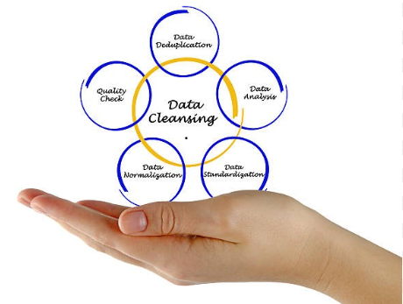

**5.BUSINESS REQUIREMENT**

To conduct a comprehensive analysis of Blinkit’s sales performance , customer satisfaction , and inventory distribution to identify key insights and opportunities for optimization various KPI’s(Key Performance Indicator) and visualizations in Power BI.

**KPI REQUIREMENT :**

1. **Total Sales :** The overall revenue generated from all item sold .
2. **Average Sales :** The Average revenue per sales .
3. **Number of items :** The total count of different items sold .
4. **Average Rating :** The average customer rating for items sold .

**CHART’S REQUIREMENT :**

1. **Total Sales By Fat Content :**

OBJECTIVE : Analyze the impact of fat content on total sales .

CHART TYPE : Donut Chart

1. **Total Sales By Item Type** :

OBJECTIVE : Identify the performance of different items in terms of total sales .

CHART TYPE : Bar Chart

1. **FAT CONTENT BY OUTLET FOR TOTAL SALES** :

OBJECTIVE : Compare total sales across different outlet segmented by fat content .

CHART TYPE : Stacked Column Chart

1. **TOTAL SALES BY OUTLET ESTABLISHEMENT :**

OBJECTIVE : Evaluate how age and type of establishment influence total sale .

CHART TYPE : Line Chart

1. **SALES BY OUTLET SIZE :**

OBJECTIVE : Analyze the correlation between outlet size and total sales .

CHART TYPE : Donut Chart

1. **SALES BY OUTLET LOCATION :**

OBJECTIVE : Access the geographical distribution of sales across different locations .

CHART TYPE : Funnel Map

1. **ALL METRICS BY OUTLET TYPE :**

OBJECTIVE : Provide a comprehensive view of all key .

CHART TYPE : Matrix Card

1. **Insights Derived from Each Chart**

Donut Chart: Revealed that certain product categories, such as fresh produce and dairy, were the top revenue generators. This insight helped in strategic planning for inventory management and promotional activities.

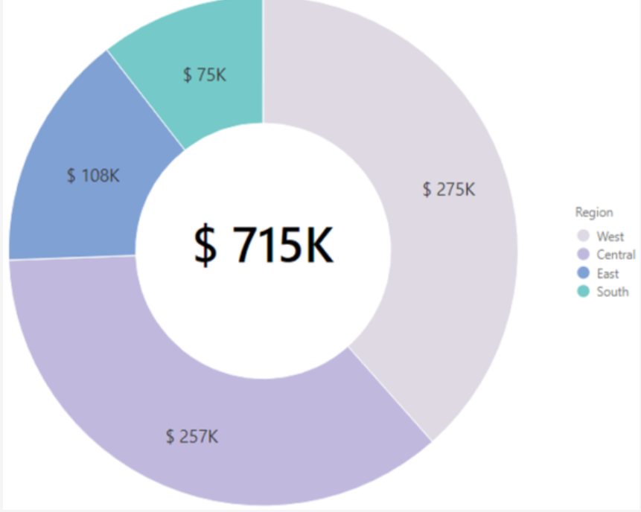

**Matrix Chart**: This chart showed that sales were higher in urban areas than in rural areas, and certain months, like December, had peak sales due to holiday shopping. This information helped optimise inventory levels and plan marketing campaigns.

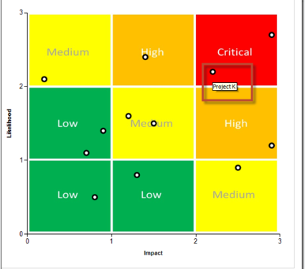

**Clustered Bar Chart**: Indicated that regions with higher sales also had more customer complaints, suggesting a need for improving service quality in those areas. It also highlighted underperforming regions that required targeted marketing efforts.

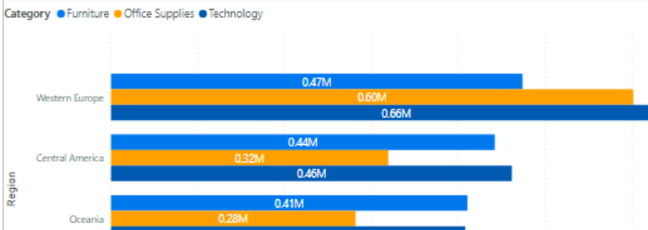

**Stacked Bar Chart**: Demonstrated that while some segments, like premium products, had higher sales, they also had a lower inventory turnover, indicating overstocking issues. This prompted a review of stocking policies.

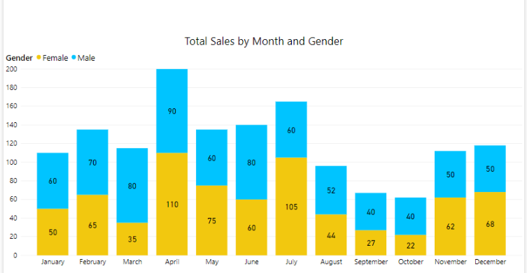

**Line Chart**: Identified consistent growth in sales over the last four quarters but also revealed a significant drop during a specific period, which was traced back to a supply chain disruption. This led to measures to strengthen supply chain resilience.

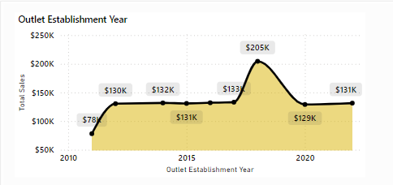

**Slicers**: Allowed detailed analysis of customer purchasing patterns by applying filters for different demographics and regions. This interactive feature facilitated tailored marketing strategies.

**Metrics**: Provided a snapshot of critical performance indicators, such as a steady increase in the average order value, which indicated effective upselling strategies. It also showed a dip in the customer satisfaction score, prompting an immediate review of customer service protocols.

**Cards**: Highlighted that the total number of new customers had increased by 20% in the last quarter, signalling successful customer acquisition strategies. It also revealed that the inventory turnover rate was slower than industry benchmarks, indicating a need for inventory optimisation.

### 7 . DASHBOARD DEVELOPMENT

The development of the dashboard for the "**Blinkit Analysis Using Power BI Dashboard"** project was a crucial phase that transformed our data insights into an interactive and user-friendly visual representation. Utilizing Power BI, the project team focused on designing a comprehensive dashboard that catered to the diverse needs of stakeholders. The goal was to create a visually appealing interface that could effectively communicate key performance indicators (KPIs) and trends, enabling users to make informed decisions quickly.

### A . Interactive Visualizations

Central to the dashboard’s effectiveness were the various visualizations employed to present the data. We incorporated bar charts to illustrate total sales over specific time periods, allowing stakeholders to easily identify trends and fluctuations in revenue. Line graphs were used to depict sales trajectories, highlighting growth patterns and seasonal variations that could inform future marketing strategies. Additionally, pie charts provided a clear representation of customer retention rates and product sales distribution, enabling stakeholders to assess which customer segments were most valuable and which products were performing well. Geographic maps further enriched the dashboard by visualizing sales data across different regions, offering insights into geographic performance and identifying areas for potential market expansion. These interactive visual tools not only enhanced the dashboard's aesthetic appeal but also allowed users to engage with the data more dynamically, facilitating deeper analysis and exploration of the information presented.

**B . Monitoring Key Performance Indicators (KPIs)**

By integrating these diverse visualizations, the dashboard served as a centralized hub for monitoring essential KPIs. Stakeholders could effortlessly track total sales figures, average order values, and customer retention rates at a glance. This real-time visibility into performance metrics was instrumental for strategic planning and operational adjustments. The interactive nature of the dashboard allowed users to filter data by various dimensions, such as time frames, customer segments, and product categories, providing tailored insights that addressed specific business questions. Ultimately, the development of this Power BI dashboard not only streamlined data analysis but also empowered stakeholders to make data-driven decisions, fostering a culture of analytics within Blinkit. The dashboard became an essential tool for driving business performance, enhancing collaboration among teams, and supporting Blinkit's growth in the competitive online grocery market.

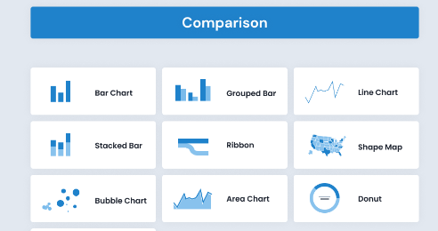

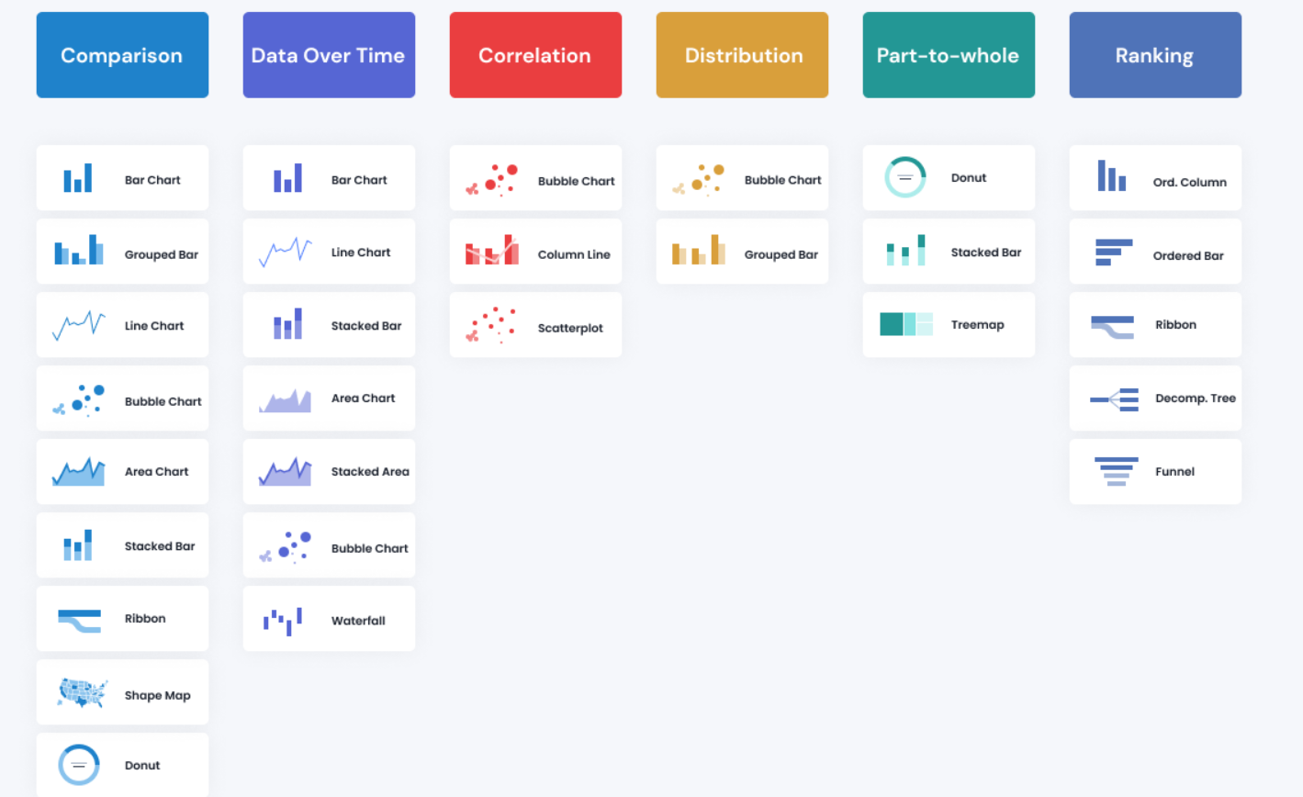

**8.Insights Generation and Analysis**

Once the Power BI dashboard was fully operational, I shifted my focus to analyzing the visualized data to derive actionable insights that could drive strategic decision-making for Blinkit. This phase involved a comprehensive examination of the metrics presented on the dashboard, allowing me to uncover significant trends, understand customer behaviors, and evaluate product performance.

**9.INFERENCE**

The Blinkit Data Analysis project using Power BI effectively addressed vital business questions through a series of interactive and insightful visualisations.

* **Sales Trends**: Consistent growth and identification of peak sales periods aid in strategic planning and resource allocation.
* **Customer Demographics**: Understanding customer demographics helps tailor marketing campaigns and improve customer service.
* **Inventory Optimisation**: Insights into stock levels and turnover rates support better inventory management, reducing overstock and stockout risks.
* **Delivery Efficiency**: Analysing delivery times and success rates helps optimise logistics and improve customer satisfaction.
* **Sales Performance**: Comparative analysis of sales performance across regions and categories informs strategic decisions to boost underperforming areas and leverage successful strategies.

**10.OUTCOME**

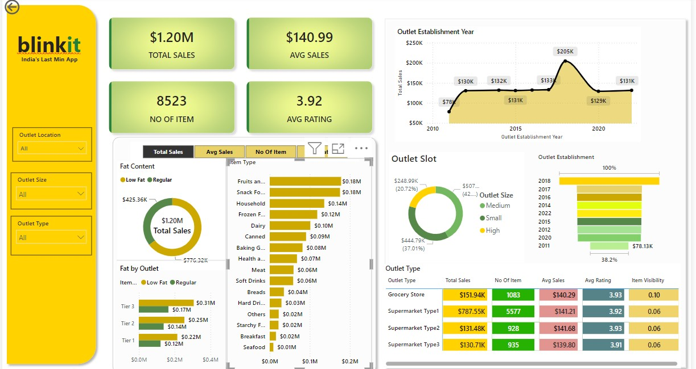

**11. CONCLUSION**

In summary, the "Blinkit Analysis Using Power BI Dashboard" project serves as a crucial initiative to harness the power of data analytics for improved business performance. By transforming raw sales data into actionable insights through a visually appealing and interactive dashboard, Blinkit aims to enhance its operational strategies and better serve its customers in the competitive online grocery market.